40.8: a) The third excited state is 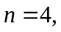so
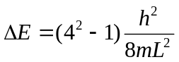
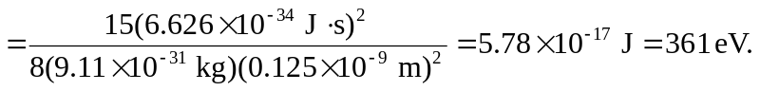
b) 